Produced by solo entrepreneur A.V. Efimov for “Element” LLC

Manual Label Applicator

OPERATION MANUAL

L 001.00.00.00 OM

Samara, Russia
This operating manual is intended to study the design and operation of Manual Label Applicator machine (hereinafter "machine") and contains the information necessary for its technically correct installation, adjustment, adjustment, operation and maintenance.
Compliance with the established provisions and standards for the operation of the machine ensures its normal stable operation, serviceability and full use of its technical capabilities.
Please note that due to technical development of the design, slight discrepancies between the machine and its description in this document are possible.
- DESCRIPTION AND OPERATION

1.1. PURPOSE OF THE MACHINE
The Manual Label Applicator machine (hereinafter the machine) is designed to manually apply an annular or segmental self-adhesive label to a round (cylindrical) container (bottle, can, jar, and other).

The machine is manufactured in a climatic version - moderately cold climate, category – 4.2 for work in areas with a temperate and cold climate, indoors, in the absence of direct solar radiation and atmospheric precipitation, wind, sand and dust of the outside air in accordance with GOST 15150-69.

The requirements for the dustiness of the atmosphere and its composition must correspond to the operating conditions group -1, the type of atmosphere - II in accordance with GOST 15150-69.
Operating conditions:
- operating temperature range - from +5 to + 40 ° С
- relative humidity,% - no more than 80 at 25 ° С
- atmospheric pressure, kPa - from 84 to 107

  - BASIC TECHNICAL DATA

Specifications are shown in table 1.
Table 1.
Parametre | Unit of measurement | Quantity
Capacity | Labels/hour | 300-600
Max label height | mm | 200
Container diametre | mm | 10 - 200
Max diametre of the labels roll | mm | 250
Number of attendants | persons | 1
Machine dimensions: lenght, width, height | mm | 300х450х250
Weight | kg | 5

ATTENTION! CONTAINER REQUIREMENTS

NOT ALLOWED:
- conical shape of the container in the area of application of the ring label (on the apparatus for cylindrical containers);
- deformation of the container.

The labeling area should have a smooth cylindrical surface and should not have protrusions, depressions, etc. that are transverse to the label.
If the container is non-standard, it is recommended to send a sample to the manufacturer for testing.

ATTENTION! LABEL REQUIREMENTS

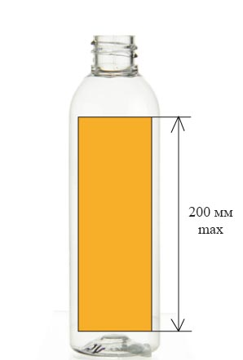  Fig. 1 Label height | The machine is designed for applying self-adhesive transparent and matte labels on an opaque substrate. If the label is non-standard (super-transparent, curly, etc.), it is recommended to send a sample to the manufacturer for testing.  Label size  The optimal label height is up to 200 mm (fig. 1).

Types of wrapping labels on a roll
For most cases, types # 4 and # 7 are suitable. For containers less than 200 mm high, types 3, 4, 7, 8 are suitable (Fig. 2).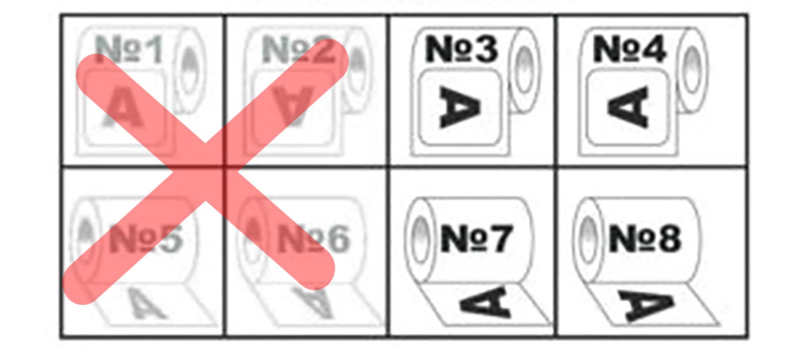
Fig. 2 Types of wrapping labels on a roll

  - . MACHINE STRUCTURE

The machine structure is shown on Fig.3.
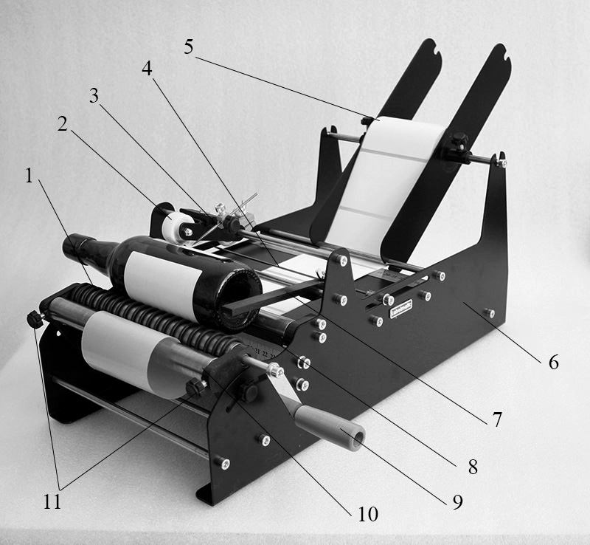
Fig. 3. Machine structure
1 - Drive shaft; 2 - Pressure roller; 3 - Mark for the counter-label;
4 - Stop mark; 5 – Label roll holder; 6 - Frame; 7 - Stopper;
8 - Squeegee; 9 - Drive shaft handle; 10 - Pressure shaft; 11 - Fixing screws.

  - MACHINE OPERATION

1. To get started, adjust the distance between the shafts so that the container is set as deeply as possible between the shafts, but does not touch the squeegee (the plate that removes the label). The optimal distance between the container and the squeegee is 2-3 mm.
2. After the distance is set for the container, install a roll of labels. The end of the strap is clamped between the two shafts (drive and pressure) with fixing screws tightly but without excessive force.

ATTENTION! OVER-TIGHTENING OF THE RETAINING SCREWS MAY CAUSE THE MACHINE BREAKAGE!

3. Rotate the handle clockwise, to pull label tape until the edge of the label is 1mm above the squeegee.
4. Then move the stop mark to the gap between the labels.
5. Place the container in the device in the desired position and fix it with a stopper. This will ensure that the label is applied at the same height throughout the batch.
6. For immobility, the container is pressed against the shafts by a spring-loaded pressure roller.
7. After completing all settings, transfer the label to the container by rotating the handle clockwise. Stop when the next label aligns with the stop mark.
2. SAFETY MEASURES
IT IS FORBIDDEN TO USE THE MACHINE:
- NOT FOR IT’S PURPOSE;
- IN CASE OF VISIBLE SHAFT AND FRAME BREAKAGE.
If the machine breaks down, work should be stopped immediately. Work can be resumed only after taking measures to ensure safe working conditions.

3. MAINTENANCE AND STORAGE

Taking good care of your machine will increase its uptime. The maintenance personnel must know the structure and interaction of the main mechanisms of the machine, be able to make adjustments, carefully clean the machine and the workplace.
In case of breakdowns that cause machine downtime, the worker should immediately contact the manufacturer.

The storage conditions of the machine in terms of the impact of climatic environmental factors must correspond to the conditions:
Temperature: -10 ° to + 40 ° С;
Относительная влажность воздуха, верхнее значение: 80% при +25° С.
Shelf life is 12 months.

4. WARRANTY TERMS

ATTENTION! Making any structural changes to the machine (including disassembly for components) without the consent of the manufacturer is not allowed. If these conditions are not met, the manufacturer does not accept complaints from consumers and does not consider claims.
The warranty period is 12 months from the date of commissioning, but not more than 18 months from the date of sale.
Please note that due to technical development of the design, slight discrepancies between the machine and its description in this document are possible.
5. CONTACTS OF THE MANUFACTURER

Element LLC
Nigegorodskaya 270/5, 630028 Novosibirsk, Russia
E-mail: boel.shop@gmail.com

